

|  |  |  |
| --- | --- | --- |
| **Module Code** | **:** | AAPP003-4-2-ISWE – Introduction To Software Engineering |
| **Intake Code** | **:** | UCDF2009ICT(SE) |
| **Lecturer Name** | **:** | Mr.Sivananthan Chelliah |
| **Hand in Date** | **:** | 1/5/2022 |
| **Tutorial No.** | **:** | T-3 |
| **Group No.** | **:** | 6 |
| **Group Leader** | **:** | Lee Jia Kin |

|  |  |
| --- | --- |
| **Student ID** | **Student Name** |
| TP062413 | Lee Jia Kin |
| TP055326 | Lee Long Feng |
| TP055615 | Lee Bing Xuan |
| TP061658 | Nathanael Flavianus |
| TP060970 | Muhammad Firdaus bin Effendi Wong |
|  |  |
|  |  |

Table of Contents

1. Introduction 5

1.1 Project Background 5

1.2 Scope 6

1.2.1 Justification 6

1.2.2 Objectives 6

1.2.3 Product scope description 6

1.2.4 Product acceptance criteria 7

1.2.5 Constraints 7

1.2.6 Assumptions 7

1.3. Aims and Objectives 8

1.3.1 Aims 8

1.3.2 Objectives 8

2. Planning & Requirements Analysis 9

2.1 Gantt Chart 9

2.2 Functional Requirements 15

2.3 Non-functional Requirements 15

3. Logical Design Part 1 16

3.1 Use Case Diagram 16

3.2 Class Diagram 18

4. Physical Design 19

4.1 Staff Login Page 19

4.2 Home/Branches Page 20

4.3 Purchase Information Page 21

4.4 View and Print Purchase Information (Receipt) 22

4.5 Confirm Purchases 23

4.6 Member Points Earned Table 24

4.7 Member Points Check and Redeem 25

4.8 Inventory Stocks 26

4.9 Inventory Reorder 27

4.10 Inventory Table 28

4.11 Supplier Table 29

4.12 Sales Report 30

5. Implementation 32

5.1 Hardware Requirements 32

5.2 Software Requirements 33

6. Prototype 34

7. Conclusion 39

8. Logical Design Part 2 40

8a. Lee Jia Kin – Checkout and Verify Reorder Item 40

8b. Lee Long Feng – Reorder Item and Payment and Confirmation 43

8c. Lee Bing Xuan – Generate Reports (Inventory Reports and Sales Reports) 46

8d. Nathanael Flavianus – Check, Earn and Redeem Points as a Member 47

8e. Muhammad Firdaus bin Effendi Wong –Delete and Update Inventory 49

9. Methodology 51

9a. Lee Jia Kin – Waterfall Model 51

9b. Lee Long Feng – Agile Model 53

9c. Lee Bing Xuan – RAD Model 55

9d. Nathanael Flavianus – Boehm’s Spiral Model 56

9e. Muhammad Firdaus bin Effendi Wong – Prototype Model 57

10. Testing 59

10a. Lee Jia Kin – Unit Testing 59

10b. Lee Long Feng – Integration Testing 61

10c. Lee Bing Xuan – Acceptance Testing 63

10d. Nathanael Flavianus – System Testing 64

10e. Muhammad Firdaus bin Effendi Wong – Functional Testing 66

11. References 68

# 1. Introduction

## 1.1 Project Background

ShopMe is a branches grocery shop located in Klang Valley area. Currently, ShopMe has four (4) shops which is in Petaling, Gombak, Hulu Langat and Putrajaya. The shops offer various types of products including meat, dairy, frozen food, bread, cereal, rice and pasta, staples and miscellaneous food, house whole items, health and beauty items. Currently all the business processes in ShopMe are done manually. The cashier will calculate the total amount of purchase items, record the purchase made by the customer using the invoice booklet and hand out the receipt to the customer one they paid.

By the end of the day, supervisor of each ShopMe branches will refer to the invoice booklet and make a simple report using Microsoft Excel on how much sales that the store has earned and total each item sold on a day and hand over to the branch manager and store keeper. Based on the Sales Report, store keeper will use it to monitor the inventory of each item. If the quantity of the items is running low, store keeper will re-order the items through several suppliers by email.

Throughout the years, the number of the customers is increasing; the owner has found out that using manual system is not efficient for his growing business. He has decided to hire a professional developer to help him to analyse and design a solution, which would help to increase the performance of ShopMe.

In the new system, the owner wish it will help to manage the daily purchasing activities. The system will record the purchase information made by the customers including the purchase date, list of products, total unit price per item and total amount of the purchase items into database. Finally, the system will generate a receipt after payment has been made.

To maintain the level of the customer interest, the owner wants to offer a membership to his loyal customer. For each purchasing activity perform by the customers, they will earn points. Once a customer has collected enough points, customer is entitled to redeem the points with products that equal to its price. The points will be update accordingly.

Since the store sells many types of items, the store keeper needs to manage the items’ record. It would be better if there is a system that help monitoring the items inventory. Every time, when a purchase occurs the quantity of the items will be deducted from the system. This will ensure that the grocery shop has a proper monitoring of the inventory of each item. To re-order the items, the store keeper only have to choose the supplier and the notice will be sent to the respective supplier. All the product order details will be submitted to the supplier. All the items will be organized in a category. One category contains many products and each product belongs to one category. By the end of each weeks or month, the branch manager should be able to generate reports so that the business performance can be monitored.

## 1.2 Scope

### 1.2.1 Justification

Our project came to be when the owner of ShopMe found out that the manual system is not as efficient as it used to be due to the growing increase of customers. With the growing number of customers, the manual systems will take longer than those digitally and the customers will be more frustrated at the speed of the old system. The managers of each branch will also need to memorize or write down the sales earned, and each item sold. The new system will allow automatic observation and is able to record it to Excel immediately. The cashiers will also not feel overwork as in the old system, as they need to calculate the total amount of purchased goods and record it in a booklet.

### 1.2.2 Objectives

The main objective of this project is to deliver an information system that will take over the business operation to support the growth of the ShopMe business and increase the business’ productivity.

### 1.2.3 Product scope description

1. Manage Daily Sales – record and update the daily sales information that are made by the customers into the database and it will generate a receipt to the customer after payment.

2. Manage Inventory – Maintain and update the item’s inventory information in the database and storekeepers only need to choose the supplier to submit their order details to re-order items.

3. Manage Branches – Modify, update, add the available ShopMe branches information in the database.

4. Manage Supplier – Maintain and update an accurate list of supplier information in the database.

5. Generate reports such as Sales Report, Inventory Report and other reports.

### 1.2.4 Product acceptance criteria

After completing this project, the owner of ShopMe can expect the business cost to not increase despite the growth of the business and potential increase in profit due to the new management system will be more efficient in handling all of the daily operations and it requires less staff to manage the system, thus it will reduce the cost of hiring more employees. Moreover, it will save a lot of time for the staff to monitor the items from the inventory.

### 1.2.5 Constraints

Given the limited time to complete this project, the first constraint would be time constraint. When it comes to time constraint, proper flow of planning is needed to be done which could sometimes take up a lot of time. Other than that, we lack professionals in the team to guide us internally which makes it a constraint to complete the system perfectly. Next, the movement restriction due to Covid-19 pandemic makes it harder for us to communicate since all of the communication are done virtually. The communication might not be effective due to technical issues, visual and audio only, and interaction between participants are difficult. These constraints might affect the time of the project to be completed. Furthermore, budget could be one of the constraints to our system. Therefore, the budget might not meet the requirements to complete the system.

### 1.2.6 Assumptions

In the progress of completing the system, we had to create a project assumption to make the flow of the plan smoother. Hence, the assumption categories in our plan are resources, budget, and service. Our team member will have the resources they need to complete their individual tasks from specialized equipment and software down to electricity during working hours. For the budget category, we assume that the costs of the material and resource will remain unchanged as initially budgeted costs. Finally for the service, our system is only for the local market, thus it will not be available for international market.

## 1.3. Aims and Objectives

### 1.3.1 Aims

The project aim is to critically assess the current business and sales operations of ShopMe in order to identify the factors which can contribute to performance and work efficiency.

### 1.3.2 Objectives

* To critically assess the manual and inefficient management system that is being used by ShopMe.
* To classify and evaluate the business operation of ShopMe.
* To make recommendations to improve the operational effectiveness of, and to maximise the business opportunities of ShopMe.

# 2. Planning & Requirements Analysis

## 2.1 Gantt Chart

Table 1: Project Plan of ShopMe Management System

|  |  |  |  |  |
| --- | --- | --- | --- | --- |
| **No** | **Task Name** | **Duration (days)** | **Start Date** | **End Date** |
| **1** | **1. Introduction** | **6** | **20-Feb-22** | **26-Feb-22** |
| 1.1 | 1.1 Project Background | 1 | 20-Feb-22 | 21-Feb-22 |
| 1.2 | 1.2 Scope | 2 | 21-Feb-22 | 23-Feb-22 |
| 1.3 | 1.3 Aims and Objectives | 2 | 23-Feb-22 | 25-Feb-22 |
| **2** | **2. Planning & Requirements Analysis** | **6** | **27-Feb-22** | **5-Mar-22** |
| 2.1 | 2.1 Gantt Chart | 1 | 27-Feb-22 | 28-Feb-22 |
| 2.2 | 2.2 Functional Requirements | 3 | 28-Feb-22 | 3-Mar-22 |
| 2.3 | 2.3 Non-Functional Requirements | 2 | 3-Mar-22 | 5-Mar-22 |
| **3** | **3. Logical Design Part 1** | **10** | **6-Mar-22** | **16-Mar-22** |
| 3.1 | 3.1 Use Case Diagram | 5 | 6-Mar-22 | 11-Mar-22 |
| 3.2 | 3.2 Class Diagram | 4 | 11-Mar-22 | 15-Mar-22 |
| **4** | **4. Physical Design** | **8** | **17-Mar-22** | **25-Mar-22** |
| **5** | **5. Implementation** | **5** | **26-Mar-22** | **31-Mar-22** |
| 5.1 | 5.1 Hardware Requirements | 2 | 26-Mar-22 | 28-Mar-22 |
| 5.2 | 5.2 Software Requirements | 2 | 28-Mar-22 | 30-Mar-22 |
| **6** | **6. Prototype** | **10** | **31-Mar-22** | **10-Apr-22** |
| **7** | **7. Conclusion** | **1** | **10-Apr-22** | **11-Apr-22** |
| **8** | **8. Logical Design Part 2** | **5** | **12-Apr-22** | **17-Apr-22** |
| **9** | **9. Methodology** | **6** | **12-Apr-22** | **18-Apr-22** |
| **10** | **10. Testing** | **6** | **12-Apr-22** | **18-Apr-22** |

**Summary Gantt Chart**

Figure 1: Summary Gantt Chart for ShopMe Management System

**Detailed Gantt Chart**

Figure 2: Detailed Gantt Chart for ShopMe Management System

According to the gantt chart, it consists of 10 main tasks to be completed in around 2 months from 20 Feb 2022 until 18 April 2022. First, we start off with the introduction phase where we have to gather information about the project background, project scope and identify the project’s aim and objectives. The whole phase will take us 6 days to complete from 20 Feb 2022 until 26 Feb 2022. As for the second main component, it will be planning and requirements analysis. This is where we plan our project schedule by using gantt chart and collect functional and non-functional requirements from our requirements gathering to understand or include the necessary features of the system. The whole process will take us 6 days to complete starting from 27 Feb 2022 until 5 Mar 2022. Next, it will be the logical design part 1. This is where we have to design use case and class diagrams to understand our system’s operation and overall design better. The process will take 10 days to complete from 6 Mar 2022 until 16 Mar 2022. Moving on, the fourth main component will be physical design. In this phase, we will be starting to design the management system’s user interface and main features but it is still not fully functional and still yet to implement into computers. This whole segment will take 8 days to complete starting from 17 Mar 2022 until 25 Mar 2022. So, the fifth phase will be the implementation. This is where we decide on how to implement the ShopMe management system by identifying the hardware and software requirements for ShopMe. The whole task will take us 5 days to complete starting from 26 Mar 2022 until 31 Mar 2022. Afterwards, we have to start creating the prototype of the management system. The prototype will be used to identify any errors of the system and receive more feedbacks from the other users to improve the system. The process will take 10 days to complete starting from 31 Mar 2022 until 10 Apr 2022. Next, we will have to prepare a conclusion for our project. In the conclusion, we will discuss about our limitations, challenges and further enhancement in the future. This phase will only take 1 day from 10 Apr 2022 until 11 Apr 2022. On to the individual components, there are 3 main components that we have to complete and we can start all of it simultaneously. First, it will be the logical design part 2. In this part, each of us will have to create activity diagrams based on the use case diagram in logical design part 1. This will take us 5 days to complete from 12 Apr 2022 until 17 Apr 2022. Next, it will be the methodology. Each of us will have to select and explain our chosen methodology and the methodology’s phases. This will also take us 5 days to complete from 12 Apr 2022 until 17 Apr 2022. Finally, the last main component is testing where each of us will have to choose a different testing method and prepare test scripts based on our previous activity diagrams. This will take 6 days to complete from 12 Apr 2022 until 18 Apr 2022.

**Summary Workload Matrix**

Figure 3: Summary Workload Matrix

**Detailed Workload Matrix**

Figure 4: Detailed Workload Matrix

## 2.2 Functional Requirements

1. ShopMe staff should be able to log in as cashier or admin.

2. System should record information about the purchases made by customer, including date, products bought, total unit price per item and total amount of the purchase’s items.

3. Cashier should use the system to print the receipt for the customer.

4. Customer should pay their items via cash or points as a member.

5. The system should be able to help members to accumulate points to redeem price that is equal with the points.

6. Member should check up their membership points.

7. The storekeepers should use the system to keep track of the items left to easily manage the stocks.

8. The storekeepers should re-order the items by choosing and submitting product order details to the supplier.

9. The storekeepers should update the inventory table after re-ordering the items.

10. The branch manager should use the system to generate reports about daily, weekly, monthly, and yearly sales.

11. Each supervisor from different branches should send the reports about the sales and quantity of items to restock to each branch manager.

12. The system should manage user management, track employees’ hours weekly and over time.

13. Sometimes staff may key the wrong transaction or wants to remove unwanted records, thus there’s a void function for them to use.

## 2.3 Non-functional Requirements

1. Each request should be processed within 6 seconds.

2. Reports must be sent with a 20ms latency.

3. The interface of the new system must be user-friendly and simple to navigate.

4. If a serious problem occurs on the new system, the company must take steps to restore full functionality within two days.

5. If the automated report services become unavailable, they may be under maintenance for approximately four hours.

# 3. Logical Design Part 1

## 3.1 Use Case Diagram

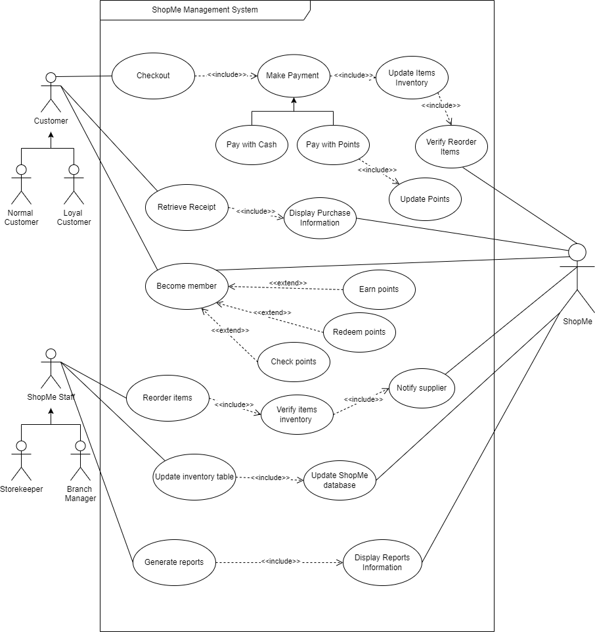

Figure 5: Use Case Diagram of ShopMe Management System

The above use case diagram is to represent how the ShopMe management system work. The actors of this system includes customer with the generalization of normal customer and loyal customer, ShopMe staff with the generalization of storekeeper and branch manager, these two actors are primary actors. Meanwhile, the ShopMe system will be our secondary actor. When the customers interact with checkout, they will have to make their payment as cash or points. If they used points, it will be updated accordingly. Afterwards, the items inventory will be updated and it will verify if the items are required to reorder within the ShopMe system. If the customers wants to retrieve their receipt, it will display their purchase information by ShopMe system. Moreover, they can be a member if they accept the membership offer from the ShopMe owner. As a member, they can earn, redeem and check their points to purchase items with their points instead. For the ShopMe staff, they can reorder items when it reaches certain amount of reorder level. After that, they can verify the items inventory to check if it’s necessary to restock and notify the respective suppliers to reorder the items. In addition, they can update the inventory table after they have received their stocks from the suppliers which means it will update the ShopMe database as well. Last but not least, they can generate reports such as weekly sales and monthly sales and display the reports information to monitor their business from the ShopMe system.

## 3.2 Class Diagram

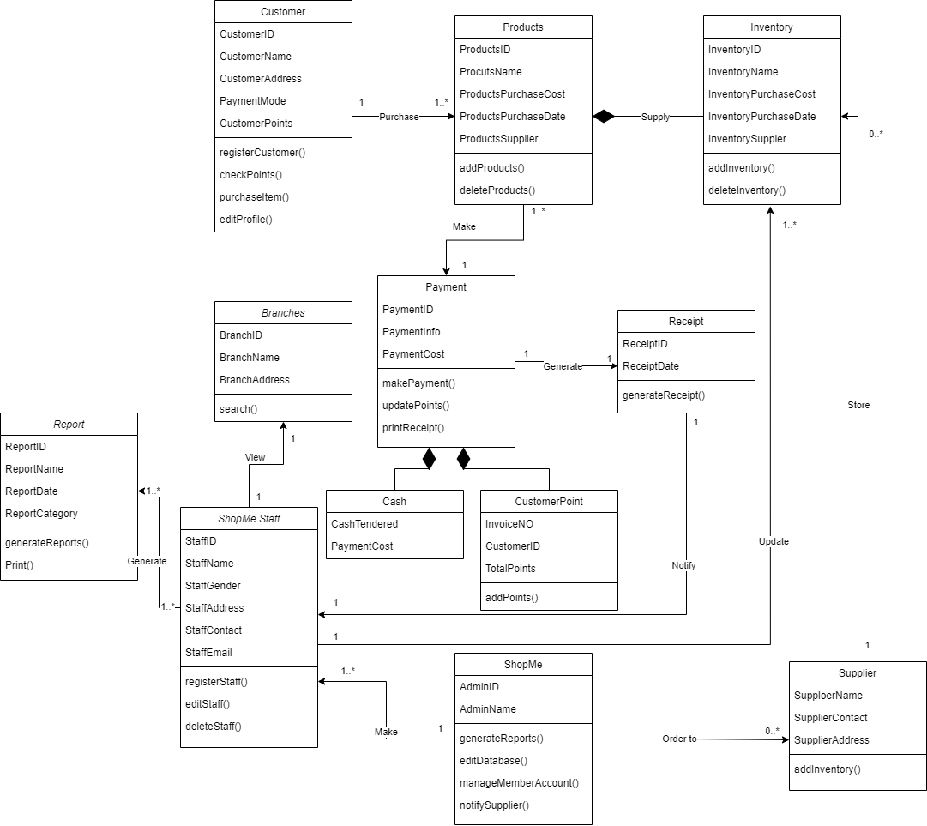

Figure 6: Class Diagram of ShopMe Management System

There is a total of 12 Class as shown in Figure 6. There are 3 main actors in the upcoming system, which are Customer, ShopMe Staff, and ShopMe. First, ShopMe can assign or register 1 or many ShopMe Staff. They are also able to notify supplier to make order to fill up their Inventory. Then, the supplier will store the ordered items in ShopMe’s Inventory which then will be supplied to Products in every branches. Next, the ShopMe Staff has a couple of function includes, viewing every branch, and generate reports with ReportID, ReportName, ReportDate, and ReportCategory. Last but not least, the customer. Every customer can purchase 1 or multiple products from the store. Upon purchasing, payment must be made in order for customer to own the items, which can be done with either cash or using customer point. After each payment are being completed, 1 receipt will be generated which will notify the ShopMe Staff.

# 4. Physical Design

## 4.1 Staff Login Page

Figure 7: Staff Login Page

Before the staff start their day off, they will have to login to access the system to manage ShopMe’s daily operational activities. ShopMe staff will have to input their username and password to login either as the cashier or the admin. They will be redirected to the home page after they login successfully.

## 4.2 Home/Branches Page

Figure 8: Home/Branches Page

After the staff has successfully login, they will be greeted by the home page also known as the branches page. ShopMe staff will need to choose the branches that they want to manage. For example, ShopMe has 4 different branches in Petaling, Gombak, Hulu Langat and Putrajaya so the system will display all those branches for the staff to choose before managing any information of the store branches.

## 4.3 Purchase Information Page

Figure 9: Purchase Information Page

After the ShopMe staff has chosen a branch to manage, the system will provide a lot of features and functions for the staff to use. One of it is the purchase information page, this page will display all of the purchase information such as the CustomerID or PurchaseID, Inventory Code, Product Name, Date, Branch Location and Total Price. They can also filter the purchase information based on the specific fields and information to search. Not only that, they can view and print the purchase information for the customers on the left side of every purchase information record.

## 4.4 View and Print Purchase Information (Receipt)

Figure 10: View and Print Purchase Information (Receipt)

When the staff has clicked on the view and print purchase information button on a particular purchase information record, it will bring them to this page. This page shows the purchase record number, the product name, the amount of purchased items, the price per item and the total prices. ShopMe staff can also print out the purchase information as a receipt for the customers to retrieve. If the staff thinks the transaction is wrong or invalid, there is a void button for them to remove the purchase information.

## 4.5 Confirm Purchases

Figure 11: Confirm Purchases

When a customer wants to pay and confirm their payments, ShopMe staff will be redirected to this page. The customer will have the option to pay in cash or points if they are a member. Before they want to pay for their purchases, the customers will have to inform the staff which payment method they will use. In this instance, the customer wants to confirm their payments using points that is equal to the item’s price. After the staff clicked on the confirm payment button, the customer will receive their receipt.

## 4.6 Member Points Earned Table

Figure 12: Member Points Earned Table

After the customer has made any purchases, if they are a member of ShopMe, they will earn points based on the items that they have bought and those information will be recorded in this page as it will display the InvoiceID, CustomerID and Points Earned from the purchase and these points will accumulate with their existing member points. The staff can also delete or update the records if necessary by clicking either of the buttons.

## 4.7 Member Points Check and Redeem

Figure 13: Member Points Check and Redeem

The member can also check their member points if they wanted to, they can simply ask the ShopMe staff to show them their member points. In this page, it will display the Customer ID, Customer IC Number, MemberID and their total member points. If the member wants to redeem their points for the next purchase, the staff can click on the redeem points button for the member to use and their points will be updated later.

## 4.8 Inventory Stocks

Figure 14: Inventory Stocks

Of course, ShopMe staff can also use this management system to monitor their item inventory stocks. In the inventory stocks page, the product pictures, product name, product id, product description and other details will be displayed. These information will be updated accordingly in the inventory table. If the staff notices an item’s stock is low, they can click on the inventory reorder button to reorder that item by notifying the supplier.

## 4.9 Inventory Reorder

Figure 15: Inventory Reorder

After the staff has clicked on the inventory reorder button, this page will be displayed to them. In this page, it will show the item’s picture and product details beside it. Moreover, the staff can input the amount of the stock that they want to reorder and submit the reorder details to the respective supplier and it will notify the supplier afterwards. They can also contact the supplier for any inquiry and update the inventory table after the new stock has come.

## 4.10 Inventory Table

Figure 16: Inventory Table

After the staff has clicked on the update table button, they will be brought to this particular page. This page contains all of the information about the item inventory. The table consists of food category, inventory code, inventory description, supplier code, balance of stock, reorder level, quantity to order, unit price and restock id. If the staff wants to update the table, they can click on the update table button and also delete a particular record by clicking on delete records if they wanted to.

## 4.11 Supplier Table

Figure 17: Supplier Table

In this page, it will display the supplier table where it consists all of the information about the suppliers that works for ShopMe. The table includes fields like supplier code, supplier name and supplier address to monitor our suppliers’ information. Like most of the table pages, it has update and delete button to manage an accurate list of suppliers information so we can keep track of our supplier and the business relationship.

## 4.12 Sales Report

Figure 18: Sales Report

If a ShopMe staff specifically the branch manager, wants to get a better understanding of the company’s business performance. They can go through this page to search for sales reports, this page shows there are 4 different types of reports which are daily sales report, weekly sales report, monthly sales report and yearly sales report. The branch manager can click on any of the reports to view the report details.

4.13 Sales Report Details

Figure 19: Sales Report Details

The branch manager will be redirected to this page after clicking on the view report button. For example, in this page it shows the daily sales report details that consists of invoice id, items sold during that day, total price and the date. If the branch manager wants to generate the report for business analysis or other purposes, they can click on generate report button.

# 5. Implementation

The implementation stage is the most common way of changing over a framework determination into an executable framework. A product configuration is a depiction of the construction of the product to be carried out, information models, interfaces between framework parts, and perhaps the algorithms utilized. Implementation is an acknowledgment of a specialized determination or calculation as a program, programming part, or other computer system through programming and arrangement. Numerous implementations might exist for a given particular or standard. There are a couple of steps on how to implement a new system in ShopMe. First of all, we need to analyse, plan, and understand the new system and how it works. We would need to know what the flaws of the current ShopMe’s system are and improve upon that in the new system. Design, Develop and Build the new system for ShopMe. We first need to design the new system to improve efficiency and to cause error on where the functions will be located. We can then develop and build a pilot system to test on how well it works. This is used to validate the system’s functionality detailed in the project plan. Next is Train, Test and Accept ShopMe’s new system. We will the begin teaching ShopMe’s staff to the accepted procedures and methodology to convey the expected usefulness of the new system. Results from this testing and preparing period should be evaluated and a close down ought to be gotten, expressing that the headway made to date is satisfactory and in accordance with the general objectives of the execution. ShopMe’s system will then be Implemented and Go-Live. ShopMe’s new bookkeeping system ought to now be finished. Its legacy data will be relocated a last opportunity to the new system and the entirety of the experience and assets of the project group are nearby and prepared to make the last change to the new system. The last step would be the Ongoing Support. With the effective send-off of ShopMe’s new system, the store's innovation accomplice ought to now keep on offering on-going support. This can be conveyed through an assistance helpdesk, alongside the use of applications for any new updates.

## 5.1 Hardware Requirements

For a system like ShopMe to be utilized productively and precisely, all computer programming needs certain hardware parts or other programming assets to be available on a computer. These prerequisites are known as computer hardware specification and are frequently utilized as a guideline instead of an outright rule. Most ShopMe’s programming characterizes will have two arrangements of system requirements tend to increase over time. With expanding interest for higher handling power and assets in more current variants of programming, framework requirements will generally increment over the long run. Industry analysts recommend that this pattern has a greater impact in driving moves up to existing computer frameworks than mechanical headways. This is frequently joined by a Hardware Similarity List (HCL), particularly if there should be an occurrence of operating systems. An HCL records tried, viable, and once in a while incongruent equipment gadget for a specific working framework or application. The accompanying sub-areas examine the different parts of equipment necessities for this application programming:

* Processor 2.6 GHZ processor speed
* Disk Space 80 GB (counting 20 GB for information base administration system)
* SVGA colour monitor or better calibre
* RAM 512MB
* backup capacity hard disk of around 80MB
* Flash Drive for file transfer
* an enhanced keyboard
* a power stabilizer

## 5.2 Software Requirements

software requirements particular lays out the reason for understanding between customers and contractors or providers of ShopMe’s (in market driven projects, these jobs might be played by the marketing and improvement divisions) on what the product item is to do as well as what it is not expected to do. software requirements determination allows a thorough appraisal of requirements before configuration can start and lessens later upgrade. It sought to likewise give a realistic premise to assessing item expenses, risks, and timetables. The product necessities particular report enrols enough and vital prerequisites that are expected for the venture improvement. To infer the prerequisites, we really want to have a reasonable and careful comprehension of the items to be created or being created. This is accomplished and refined with itemized and nonstop interchanges with the task group and client till the finish of the product. The necessities for the software requirements of ShopMe’s include:

* Operating System; Windows 7/8/10
* Microsoft Visual Studio 2013 (Front End)
* MySQL information base (Back End)
* Visual C# Programming

# 6. Prototype

**Login Page**

Figure 20: Login Page

**Main Page**

Figure 21: Main Page

**Purchase Information Page**

Figure 22: Purchase Information Page

**Member Points Earned Page**

Figure 23: Member Points Earned Page

**Member Points Check and Redeem Page**

Figure 24: Member Points Check and Redeem Page

**Inventory Stocks Page**

Figure 25: Inventory Stocks Page

**Inventory Reorder Page**

Figure 26: Inventory Reorder Page

**Inventory Table**

Figure 27: Inventory Table

**Supplier Table**

Figure 28: Supplier Table

**Sales Report Page**

Figure 29: Sales Report Page

**Sales Daily Report Page**

Figure 30: Sales Daily Report Page

# 7. Conclusion

In the conclusion, there’s one limitation which is the inventory data will be recorded when the goods are arrive but if the stock is not fully delivered, the owner must check it manually instead of the auto notifying. Besides that, we’ve faced quite several challenges throughout this assignment. As Nathanael is from Indonesia so there’s time different and sometimes it is quite difficult to match the time for meeting but thanks to Nathanael, he made it every time. Other than that, time management as we have other assignments and stuffs to do, and we decided to free some time to update the progression of the assignment every day. Finally, for the future enhancement, we will constantly add functions and improve the design of the system so that users will feel good while using it and we think that this module is going to be helpful to our assignments in the future. In this module, all of us have learned much knowledge of it and specially thanks to our lecturer for the guidance and the patience.

**Individual Component**

# 8. Logical Design Part 2

## 8a. Lee Jia Kin – Checkout and Verify Reorder Item

**Checkout - Activity Diagram**

Figure 31: Checkout Activity Diagram

When a customer wants to checkout items that they want to buy at the checkout counter, they will have to make payment either using cash or points that they have accumulated from previous purchases. If the customer wants to purchase items using points, their points will be deducted according to the item’s price and their points will be updated. Meanwhile, if the customer wants to purchase items using only cash, the cash amount will be calculated by the cashier. After the customer has paid using either of the payment methods, the purchase information will be recorded by the system and store it in the ShopMe database. Furthermore, the system will generate a receipt that contains the purchase information earlier and the customer can receive the receipt to view the purchase information.

**Verify Reorder Item – Activity Diagram**

Figure 32: Verify Reorder Item Activity Diagram

The sequence of this activity diagram is similar to the previous activity diagram, where a customer can make payment using either points or cash to purchase their items during their checkout. If the customer uses points, it will deduct their points and update it accordingly while cash will deduct the customer’s money amount. Afterwards, the system will record the purchase information of the items and store it in the database. Later, it will deduct the item inventory based on the amount of purchased items that the customer has bought and update the item inventory. Therefore, the system will have to verify the item inventory whether it is under or still above the reorder level. If the reorder level is under, the system will notify the ShopMe staff immediately whereas if it is above, it will continue to generate receipt of the purchase information. After notifying the respective ShopMe staff, it will also generate the receipt. Finally, the customer can receive their receipt.

## 8b. Lee Long Feng – Reorder Item and Payment and Confirmation

**Reorder Item – Activity Diagram**

Figure 33: Notice About Re-Order Item Order Activity Diagram

First thing first, is the staff has to login first to the system, only then they are possible to restock on items that are low on quantity. Once they are logged in, they could use the system re-order item functions to restock the items. Once they have clicked on the functions, they are required to verify if the item is low or not, if it’s the latter, sufficient quantity, then they are not needed to restock and can end the session. If the items are low, they need to check on the quantity of it, once they know how much they need to restock, they can start the order for restocking the items. Once the order has been made, system will send a notice to the supplier and the higher up about the restock order.

**Payment and Confirmation – Activity Diagram**

Figure 34: Payment and Confirmation Activity Diagram

For the payment of the re-order item order, it will be the responsible for the branch manager, as they only have the access for it. Once logged in, they will receive a notification about the invoice from the supplier. To avoid any additional mistake, they are needed to double confirm the quantity and types of items from the invoice and the re-order item order. Once the details are the same from both, only then the branch manager will make the payment. Once payment is made, they will receive a confirmation from the supplier, and the supplier can start preparing the items needed for ShopMe.

## 8c. Lee Bing Xuan – Generate Reports (Inventory Reports and Sales Reports)

(blank)

## 8d. Nathanael Flavianus – Check, Earn and Redeem Points as a Member

**Check Points – Activity Diagram**

Figure 35: Check Points Activity Diagram

This picture shows on how the customer can check their current points. ShopMe Management system will provide the current points the customer has so the customer would only need to check their points

**Earn and Redeem Points – Activity Diagram**

Figure 36: Earn and Redeem Points Activity Diagram

In the picture above, this shows on the redeem point system for the customer. To earn points, ShopMe will send in a code for the customer to redeem in the Redeem points. In there, the customers can also check their current points.

## 8e. Muhammad Firdaus bin Effendi Wong –Delete and Update Inventory

**Delete Inventory - Activity Diagram**

Figure 37: Delete Inventory Activity Diagram

Figure # shows the activity diagram for deleting inventory. First, ShopMe Staff need to enter the Inventory menu to access the Inventory, then will be given 2 options either to delete or update inventory. If the staff choose Delete Inventory, the system will receive the request to Delete Inventory then have the Inventory deleted which will then be displayed for the staff.

**Update Inventory – Activity Diagram**

Figure 38: Update Inventory Activity Diagram

However, according to figure # if the staff chooses Update Inventory, a prompt will appear with editable text box. After updating the Inventory, the system will update the information which will then be displayed for ShopMe Staff.

# 9. Methodology

## 9a. Lee Jia Kin – Waterfall Model

After under some consideration, the system development model that I have chosen for the ShopMe information system is waterfall model. There are a few reasons why I have chosen this model to commence creating the information system. First and foremost, this model is easy to understand and implement for the our development team to work with. The model breaks down the phases in a linear-sequential matter and relatively straightforward. (Sommerville, I, 2011) In theory, each phase must to be completed before starting a next phase. Thus, there will be a review at the end of each phase to ensure the goals have been achieved and getting approved by the reviewer. Next, this model is a well-known model due to its early introduction as a process model in 1970 by Dr. Winston W. Royce and it is still being used today. The model focuses more on the logical processes that are required to conduct over the course of a software development life cycle and it can define clear steps, goals and objectives of creating an information system, which could be one of the reasons why it is still popular today. Finally, the model is easy to manage for our information system’s progress. The model provides consistent and rigid processes for us to follow throughout the project so it will be easier for us to monitor the whole progress. Also, it can arrange or divide our tasks easier as the phases are well-defined and the phases do not overlap. (Tutorialspoint, n.d)

**Phases**

As for the SDLC phases, typically there are five phases being conducted using this model which are requirements gathering and analysis, system design, implementation and unit testing, integration and system testing and operation and maintenance. The first phase of the waterfall model would be requirements gathering and analysis, this looks at the objectives, constraints, goals and requirements of the system based on the development team and potential users requests, findings, and specifcations. For example, we need to consider our timeline to finish the whole system within the time given and during requirements gathering, we have collected a lot of information from the internal staff of ShopMe and customers who visit ShopMe shops to get a better understanding of the whole project and what functionalities are required for the system. Next, it would be the system design phase where we define our systems and hardware requirements from the last phase’s deliverables and the overall architectural design of our system. In this phase, we can start designing our system by using computer-aided software engineering (CASE) tools, UML diagrams and prototyping tools to assist our design process. For example, we used use case diagrams to identify main interactions of ShopMe information system and prototyping tools to build an early version of the system to demonstrate important features for the customers to test and improve upon the system based on their feedbacks. As for the third phase, it will be implementation and unit testing. We can finally start our coding and implementing all of the required features into our system as a set of smaller programs so we can conduct our unit testing. Unit testing is a test where we test the smaller programs also known as units independently to verify their functionalities and errors before integrating these units in the next phase. For instance, we start implementing key functions for the ShopMe management system which includes generating sales reports, updating items inventory and many more into individual programs and test it individually afterwards. Moving onto the fourth phase, it will be integration and system testing. In this phase, we will integrate all of the developed units from the previous phase together into the information system and test the system as a whole to make sure that all of the requirements are met. Now, we can deliver our system to ShopMe. Finally, we can move on to the last phase which is operation and maintenance. This phase is the longest phase of all as it is an ongoing process. In this phase, we have to ensure our system is installed and operating without any problems during its operation. Moreover, we will develop and release new patches to improve the information system or to combat bugs, glitches, security issues and other errors that are not present during previous phases to improve the usability of the system. For instance, we can release a new patch to add more features to further improve the user’s experience of the ShopMe information system every 2 months.

## 9b. Lee Long Feng – Agile Model

Concept

First and foremost, in the concept phase, our product owner will confirm the scope of the project about the ShopMe new system. By looking through the scope of project, the product owner can prioritize the most important project to start first, if there are numerous projects to be done at once. After setting up the priority, they need to meet up with the ShopMe management team to discuss about the key requirements and prepare the documentation to inform them which features will be added to help them aid in the system and to outline them the proposed end result. Not only that, but our product owner also needs to estimate the time and the cost for the ShopMe project. By estimating, it can help our team to know if the ShopMe project will be easy to be execute or not.

Inception

So, first thing first in this phase, we need to define the needs of the stakeholder to achieve stakeholder agreement regarding the objectives and funding of the project. Moving on, it is time to start to build the project environment. The project owner can view the availability of their colleagues and pick the most suitable people for the project. Once done, they can start to design the process of the project. It is best for the team to create and build up the user face of the system and project workflow. During this phase, it involves further input from stakeholders to fully provide more information about the requirements on a diagram and determine the product functionality. That is why, it is best to have a regular check-in to ensure that all requirements are built into the design process.

Iteration

Moving on to the next phase is the iteration phase. This phase is also known as the construction phase, where it tends to be the longest phase as we need to carry out the work. The goal of this phase is to create a minimal functional of the system by the end of the first iteration. The developers will need to combine the system requirement of ShopMe and turning it into codes to develop the system to aid ShopMe system. This phase is the vital stage for us, as it can create working system quickly and we can make fast changes to satisfy the client. Not only that, tweaks and additional features can be added in the later iteration, making it really convenient to update the system if the clients aren’t satisfied with it.

Release

In this phase, it means that the system is almost ready to be release. But before releasing it, the quality assurance team needs to perform couple of beta testing to make sure that the system is fully functional. Not only that, but they also need to make sure that the codes are clean. If there are bugs or error in it, they are required to debug and fix the code. User training will also be implemented in this stage, as we need to provide training to the staff of ShopMe to use the newly built system, so that they will be familiar and could provide better results by using the system first-hand so they would not be confused when the system is first launched. When all of this is complete, the system’s final iteration can be launched.

Maintenance

By coming into this phase, it means that the system is successfully functional, and it has already launched. Meaning that, it is left with maintenance to help maintain the functionality of the system. During the stage of maintenance, our team will provide ongoing support to keep the system running smoothly and resolve any upcoming bugs or problems. In upcoming events the system might also add new iterations to refresh the existing system with upgrades and additional features. We will also include additional training to the ShopMe staff is there is a new function update to the system to make sure the staff know how to operate the system properly.

Retirement

For this phase to be implemented it has two reasons why this phase happened. First, the system is being replaced with a new system, meaning that the client wants to use other system that can bring much more benefits to the organization and be much more usable and better compared to our system. If this is the reason, the user will be migrated to use the new system. Second, the system itself has become incompatible with ShopMe over time. Our team will notify the user that the software is being retired. Once the system is prepared to be retired, the developers will perform any remaining end-of-life activities and remove any existing support for our system. (The Agile Software Development Life Cycle | Wrike Agile Guide, 2022)

## 9c. Lee Bing Xuan – RAD Model

The Rapid Application Development aka RAD Model is focused on prototypes and an iterative methodology with little planning. In general, taking a RAD approach to software development implies focusing less on planning and more on development and creating a prototype. There are few pros of using RAD Model, this first pro of using to this system is highly skilled developers because when we have multi-talented who can quickly adapt to new scenarios, RAD works. RAD isn't ideal for someone who is just starting out in their career and needs to spend a lot of time understanding the fundamentals of each criterion. Following by good management skills because RAD necessitates a project manager that is both adaptable and flexible, as well as results oriented. RAD might escalate into continual revisions without a clear-headed project manager, never resulting in market-ready software.

## 9d. Nathanael Flavianus – Boehm’s Spiral Model

The spiral model, first proposed by Boehm, is a transformative software process model that couples the iterative component of prototyping with the controlled and efficient parts of the direct successive model. It carries out the potential for fast advancement of new forms of the product. Utilizing the spiral model, the product is created in a progression of steady deliveries. During the early emphases, the unexpected delivery might be a paper model or prototype. During later cycles, an ever-increasing number of complete forms of the designed system are created.

Each cycle is divided into four parts that consists of: Objective setting, Risk assessment and reduction, Development and validation and lastly planning.

**Objective setting** - Each cycle in the spiral beginnings with the identification of direction for that cycle, the different choices that are workable for accomplishing the objectives and the imperatives that exists.

**Risk Assessment and Reduction** - The following stage in the cycle is to compute these different options in view of the objectives and imperatives. The focal point of assessment in this stage is situated on the gamble

**Development and Validation** - The following stage is to foster systems that settle vulnerabilities and dangers. This cycle might incorporate exercises, for example, benchmarking, simulation, or prototyping discernment for the venture.

**Planning -** At last, the following stage is planned. The venture is explored, and a decision whether to go on with a further time of the twisting. Assuming not entirely set in stone to keep, plans are drawn up for the following stage of the venture.

The gamble driven component of the spiral model permits it to oblige any combination of a detail situated, model arranged, reproduction situated, or one more kind of approach. A fundamental component of the model is that every time of the spiral is finished by an audit that incorporates every one of the items created during that cycle, including plans for the following cycle. The winding model works for advancement as well as upgrade projects.

## 9e. Muhammad Firdaus bin Effendi Wong – Prototype Model

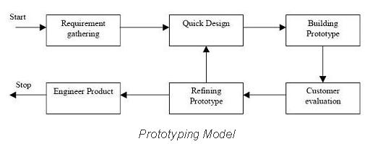

Figure 39: Prototyping Model Phases

The main purpose of prototyping model is instead of freezing requirements before moving on with design or coding, the Prototype technique creates a throwaway prototype to obtain a better grasp of the requirements. This prototype is based on currently known requirements. A prototype model is a software development approach. Interacting with the prototype may provide the customer a realistic feel for the system, since interactions with the prototype can assist the customer better understand the system's needs. For large and enormous systems with no manual technique or existing system to aid in determining needs, prototyping is a tempting notion.

Step 1: Requirement Gathering

The prototyping model starts with requirement gathering where requirements of the system will be recorded in detailed. During the process, an interview will be going on to figure out the expectations from users of the system.

Step 2: Quick Design

The next step would the quick design. In this step, a simple design of the system will be made where it is not complete. In this phase, the purpose of it is to give a brief idea of the expected system which helps the prototyping.

Step 3: Building Prototype

In this step, an actual prototype will be made with the help from quick design, based on the information collected from it. It is basically a mini version of the actual system.

Step 4: Customer Evaluation

The proposed system will then be distributed to customers or testers to evaluate them. In this stage, we should be able to figure out the advantages and disadvantages of the new system based on the customer evaluation. So, the developer can collect all of the comments and suggestion.

Step 5: Refining Prototype

This phase is meant to satisfy all the customers dissatisfaction. If the customer were not satisfied with the products, developers must keep refining or change their prototype until all the customers are satisfied.

Step 6: Engineer Product

Once the system is finalized, it will be officially implemented. The system will then undergo a series of maintenance and updates to prevent errors occurring.

Advantages of Prototype model:

* Developers and end users are both involved in the development of the system.
* End users might have better understanding regarding the system since a prototype are provided to be tested.
* Errors in the system can be easily detected and fixed with this methodology.

Disadvantages of Prototype model:

* Leads to implementing and then repairing way of building systems.
* This methodology might change the course of the goals since users will keep on requesting new functions.

# 10. Testing

## 10a. Lee Jia Kin – Unit Testing

The testing method that I have chosen is white box testing. White box testing is a testing method where the tester knows the internal structure and design of the system when testing. The developers who worked on the ShopMe management system will be testing the system as they understand the whole system’s codings, functionalities and design. The main reason to conduct this test is to verify the system’s work flow so the developers can rectify it before the implementation as the test focuses more on the main features. As for the level of testing, I have chosen unit testing as my level of testing for the ShopMe management system. There are a few justifications that this testing method is being used for ShopMe system. Firstly, this method can reduce the testing and system cost as the errors can be detected and fix it early on. Since unit testing is one of the most important tests for our development team to work on, it is a great way to confirm that the units are fully functional and reduce unnecessary time to find it in the later stages before moving on to the integration or component testing. Moreover, it can help our development team to understand our code better. During the test, we will understand better on the value we are going to input and store into the system, the information system and most importantly how our code works for the particular program. So, we can improve our code or make any changes quicker if necessary. Last but not least, we can reuse the codes for future projects or later part of the system after we have done the unit testing. This means when the codes from the current project is well-tested and it does not have any errors, we can just reuse and tweak it accordingly for our new projects when it consists similar functionalities. Plus, it can save a lot of time to code the same lines again. For our unit testing, we will write specific lines of code to test a specific feature or function and it will use automated tests to perform these tests.

**Test Scripts**

Checkout

Figure 40: Checkout Test Script

Verify Reorder Item

Figure 41: Verify Reorder Item Test Script

## 10b. Lee Long Feng – Integration Testing

In this case of scenario, the integration testing is considered as a white box testing. Why integration testing? Well, usually a complete software consists of multiple small or big modules of software altogether to make the software runnable, and its codes are usually coded by different programmer for each module to avoid time consuming. For the integration testing, it integrates the software modules logically one by one and tested the behaviour as a group. The purpose of the integration testing is that the testing is used to expose errors in the interaction between these software modules when they are integrated.

First thing first is that there are many approaches of integration testing, such as big bang, bottom-up and top-down approach. In this case scenario, the approach would be the top-down approach. This approach starts from the topmost of the module and then gradually progress down to the lowest modules. The topmost modules will be tested in isolation, usually in unit testing. After that, the lower modules are integrated one by one, the process is required to be repeated until all the modules are all tested and integrated. The advantages of doing this is that we can easily identify the error in which modules of the software. Having to test on critical modules first, major errors could be found and fixed right away using the top-down technique. Unlike the big bang approach, where we need to wait for all the modules to be done, only then it could be integrated together and then tested as a unit, thus making it really time consuming. The good thing for the top-down when a coder hasn’t finished his part yet, we replace its part with a stub (dummy program) to save time and execute the testing. (Hamilton, 2022)

It is easy to conduct the integration testing. First thing first is that we need to prepare the integration test plan. The second thing is to design the test scenario, whereas this case is the integration test, top-down approach. Once things are prepared, it is time to execute the test case followed by reporting the defects found. If there are defects found, it is best to re-track and re-test the module to find the defects. Repeat the execution part and re-testing part until all modules are tested successfully. (Software Testing Help, 2022)

**Test Scripts**

Notice About Re-Order Item Order

Figure 42: Notice About Re-Order Item Order Test Script

Payment and Confirmation

Figure 43: Payment and Confirmation Test Script

## 10c. Lee Bing Xuan – Acceptance Testing

Acceptance testing is users, clients, or other permitted entities do test to determine application/software requirements and business processes. Acceptance testing is a test used in engineering and its different subdisciplines to determine if the requirements of a specification or contract are met. It could include physical, or performance tests.

**Test Scripts**

(blank)

## 10d. Nathanael Flavianus – System Testing

White-box testing is a testing method which really takes a look at the inward working of the system. In this method, testing depends on inclusion of code proclamations, branches, ways or conditions. White-Box testing is considered as low-level testing. It is additionally called glass box, straightforward box, clear box, or code base testing. The white box Testing technique expects that the way of the rationale in a unit or program is known.

White box testing is in many cases referred to with regards to Static Application Security Testing (SAST), a methodology that checks source code or pairs naturally and gives criticism on bugs and potential weaknesses. There are 5 steps for the White Box to work for testing: Stage 1: Gather prerequisites, useful determinations, plan records, source code.

Stage 2: Testing plan planning

Stage 3: Test case planning

Stage 4: Test case execution

Stage 5: Defect Reporting and fixing issues

White Box testing is also divided in different testing that specialize in different things. **Execution Testing**: It is a white box testing type that is to test the code and contrast the real result and the normal result.

**Operation Testing**: It is a white box testing type that is to test the non-practical properties, for example, performance, load, convenience, security and so on, of the unit module.

**Mutation Testing**: It is a white box testing type that is to change (transform) certain assertions in the source code and confirm assuming the tests can track down the mistakes.

**Test Scripts**

Earn and Redeem Points

Figure 44: Earn and Redeem Points Test Script

Check Points Validation

Figure 45: Check Points Validation Test Script

## 10e. Muhammad Firdaus bin Effendi Wong – Functional Testing

Figure 46: Black Box Testing

The black box is an effective tool for testing an application from the user's point of view. Black box testing is performed to check the system for external influences that might cause software problems. This kind of testing concentrates on the data that is fed into the programme and the results that are generated. Inside aspects such as code, server logic, and development approach are not covered by the testing team. In this case, we used functional testing which is a type of inside black box testing for the testing method. This testing type only deals with the functional requirements of the new system. With this testing method, different types of functions of the system will be tested by providing inputs and comparing the expected output with an actual output from the testing. There are few major types of functional testing which includes, sanity testing, smoke testing, integration testing, and regression testing. In this case, the regression testing will be used to test the new ShopMe system. Regression testing is a sort of testing that is used to ensure that a software update does not affect the product's existing functioning. This is to guarantee that any new functionality, bug patches, or modifications to current features don't break the product. In order to validate the impact of the modification, previously performed test cases are re-executed.

**Test Scripts**

Delete and Update Inventory

Figure 47: Delete and Update Inventory Test Script

# 11. References

1. Tutorialspoint. (2022). SDLC - Waterfall Model. Tutorialspoint.

<https://www.tutorialspoint.com/sdlc/sdlc_waterfall_model.htm>

2. Lewis, S. (2019). Waterfall Model. TechTarget.

<https://www.techtarget.com/searchsoftwarequality/definition/waterfall-model>

3. Sommerville, I . (2011). Software Engineering, 9th Edition. Addison-Wesley.

4. TechTarget. (2019). Unit Testing. TechTarget.

<https://www.techtarget.com/searchsoftwarequality/definition/unit-testing>

5. Hamilton, T. (2022). Unit Testing Tutorial: What is, Types, Tools & Test EXAMPLE. Guru99.

<https://www.guru99.com/unit-testing-guide.html>

6. Hamilton, T (2022). Black Box Testing Vs. White Box Testing: Key Differences. Guru99.

<https://www.guru99.com/back-box-vs-white-box-testing.html>.

7. Tryqa. (2022). What is Prototype model- advantages, disadvantages and when to use it? Tryqa.

<http://tryqa.com/what-is-prototype-model-advantages-disadvantages-and-when-to-use-it/>.

8. Martin, M. (2022). Prototyping Model in Software Engineering: Methodology, Process, Approach. Guru99.

<https://www.guru99.com/software-engineering-prototyping-model.html>.

9. Wrike. (2022). The Agile Software Development Life Cycle | Wrike Agile Guide. Wrike.

<https://www.wrike.com/agile-guide/agile-development-life-cycle/>.

10. Hamilton, T. (2022). Integration Testing: What is, Types, Top Down & Bottom Up Example. Guru99.

<https://www.guru99.com/integration-testing.html>

11. Software Testing Help. (2022). What Is Integration Testing (Tutorial With Integration Testing Example). SoftwareTestingHelp.

<https://www.softwaretestinghelp.com/what-is-integration-testing/>